***WEBKUL PATTERN QUESTION***

1. **WAP to solve this pattern given below.**

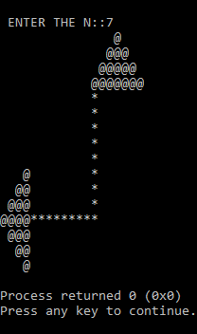

**Code::**

#include<stdio.h>

int main()

{

int i,n,j;

printf("\n ENTER THE N::");

scanf("%d",&n);

for(i=1;i<=(n/2)+1;i++)

{

for(j=1;j<=(n/2)+1;j++)

printf(" ");

for(j=1;j<=n+1;j++)

printf(" ");

for(j=i-1;j<n/2;j++)

printf(" ");

for(j=1;j<=i;j++)

printf("@");

for(j=2;j<=i;j++)

printf("@");

printf("\n");

}

for(i=1;i<=n/2+1;i++)

{

for(j=1;j<=(n/2)+1;j++)

printf(" ");

for(j=1;j<=n+1;j++)

printf(" ");

for(j=1;j<=1;j++)

printf("*");

printf("\n");

}

for(i=1;i<=1;i++)

{

for(j=1;j<=(n/2)+1;j++)

printf(" ");

for(j=1;j<=n+1;j++)

printf(" ");

for(j=1;j<=1;j++)

printf("*");

printf("\n");

}

for(i=1;i<=n/2;i++)

{

for(j=i;j<=n/2;j++)

printf(" ");

for(j=1;j<=i;j++)

printf("@");

for(j=1;j<=n+1;j++)

printf(" ");

for(j=1;j<=1;j++)

printf("*");

printf("\n");

}

for(i=1;i<=1;i++)

{

for(j=1;j<=n/2+1;j++)

printf("@");

for(j=1;j<=n+2;j++)

printf("*");

printf("\n");

}

for(i=1;i<=n/2;i++)

{

for(j=1;j<=i;j++)

printf(" ");

for(j=n/2;j>=i;j--)

printf("@");

printf("\n");

}

return 0;

}

1. **WAP to solve this pattern Given below.**

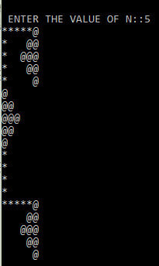

**Code::**

#include<stdio.h>

int main()

{

int i,n,j;

printf("\n ENTER THE VALUE OF N::");

scanf("%d",&n);

for(i=1;i<=1;i++)

{

for(j=1;j<=n;j++)

printf("*");

for(j=1;j<=1;j++)

printf("@");

printf("\n");

}

for(i=1;i<=n/2;i++)

{

for(j=1;j<=1;j++)

printf("*");

for(j=1;j<=n/2;j++)

printf(" ");

for(j=i;j<=n/2-1;j++)

printf(" ");

for(j=1;j<=i+1;j++)

printf("@");

printf("\n");

}

/*for(i=1;i<=1;i++)

{

for(j=1;j<=1;j++)

printf("*");

for(j=1;j<=n/2;j++)

printf(" ");

for(j=1;j<=n/2+1;j++)

printf("@");

printf("\n");

}*/

for(i=1;i<=n/2;i++)

{

for(j=1;j<=1;j++)

printf("*");

for(j=1;j<=n/2;j++)

printf(" ");

for(j=1;j<=i;j++)

printf(" ");

for(j=i;j<=n/2;j++)

printf("@");

printf("\n");

}

for(i=1;i<=n/2+1;i++)

{

for(j=1;j<=i;j++)

printf("@");

printf("\n");

}

for(i=1;i<=n/2;i++)

{

for(j=n/2;j>=i;j--)

printf("@");

printf("\n");

}

for(i=1;i<=n-1;i++)

{

for(j=1;j<=1;j++)

printf("*");

printf("\n");

}

for(i=1;i<=1;i++)

{

for(j=1;j<=n;j++)

printf("*");

for(j=1;j<=1;j++)

printf("@");

printf("\n");

}

for(i=1;i<=n/2;i++)

{

for(j=1;j<=n/2+1;j++)

printf(" ");

for(j=n/2-1;j>=i;j--)

printf(" ");

for(j=1;j<=i+1;j++)

printf("@");

printf("\n");

}

for(i=1;i<=n/2;i++)

{

for(j=1;j<=n/2+1;j++)

printf(" ");

for(j=1;j<=i;j++)

printf(" ");

for(j=n/2;j>=i;j--)

printf("@");

printf("\n");

}

return 0;

}

1. **WAP to solve this pattern Given below.**

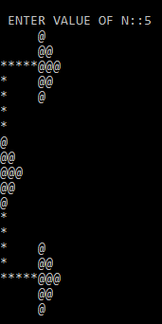

**Code::**

I have solved this with two different types as

**TYPE 1::**

#include<stdio.h>

int main()

{

int i,j,n;

printf("\n ENTER VALUE OF N::");

scanf("%d",&n);

for(i=1;i<=n/2;i++)

{

for(j=1;j<=n;j++)

printf(" ");

for(j=1;j<=i;j++)

printf("@");

printf("\n");

}

for(i=1;i<=1;i++)

{

for(j=1;j<=n;j++)

printf("*");

for(j=1;j<=n/2+1;j++)

printf("@");

printf("\n");

}

for(i=1;i<=n/2;i++)

{

for(j=1;j<=1;j++)

printf("*");

for(j=1;j<=n-1;j++)

printf(" ");

for(j=n/2;j>=i;j--)

printf("@");

printf("\n");

}

for(i=1;i<=n/2;i++)

{

for(j=1;j<=1;j++)

printf("*");

printf("\n");

}

for(i=1;i<=n/2+1;i++)

{

for(j=1;j<=i;j++)

printf("@");

printf("\n");

}

for(i=1;i<=n/2;i++)

{

for(j=n/2;j>=i;j--)

printf("@");

printf("\n");

}

for(i=1;i<=n/2;i++)

{

for(j=1;j<=1;j++)

printf("*");

printf("\n");

}

for(i=1;i<=n/2;i++)

{

for(j=1;j<=1;j++)

printf("*");

for(j=1;j<=n-1;j++)

printf(" ");

for(j=1;j<=i;j++)

printf("@");

printf("\n");

}

for(i=1;i<=1;i++)

{

for(j=1;j<=n;j++)

printf("*");

for(j=1;j<=n/2+1;j++)

printf("@");

printf("\n");

}

for(i=1;i<=n/2;i++)

{

for(j=1;j<=n;j++)

printf(" ");

for(j=n/2;j>=i;j--)

printf("@");

printf("\n");

}

return 0;

}

**TYPE2::**

#include<stdio.h>

int main()

{

int i,j,n;

printf("\n ENTER VALUE OF N::");

scanf("%d",&n);

for(i=1;i<=n+n/2;i++)

{

if(i>=1 && i<=n/2)

{

for(j=1;j<=n;j++)

printf(" ");

for(j=1;j<=i;j++)

printf("@");

printf("\n");

}

else if(i>n/2 && i<=n)

{

if(i==n/2+1)

{

for(j=1;j<=n;j++)

printf("*");

for(j=1;j<=n/2+1;j++)

printf("@");

printf("\n");

}

else

{

for(j=1;j<=1;j++)

printf("*");

for(j=1;j<=n-1;j++)

printf(" ");

for(j=n;j>=i;j--)

printf("@");

printf("\n");

}

}

else

{

for(j=1;j<=1;j++)

printf("*");

printf("\n");

}

}

for(i=1;i<=n+n/2;i++)

{

if(i>=1 && i<=n/2+1)

{

for(j=1;j<=i;j++)

printf("@");

printf("\n");

}

else if(i>n/2+1 && i<=n)

{

for(j=n;j>=i;j--)

printf("@");

printf("\n");

}

else

{

for(j=1;j<=1;j++)

printf("*");

printf("\n");

}

}

for(i=1;i<=n;i++)

{

if(i>=1 && i<=n/2)

{

for(j=1;j<=1;j++)

printf("*");

for(j=1;j<=n-1;j++)

printf(" ");

for(j=1;j<=i;j++)

printf("@");

printf("\n");

}

else

{

if(i==n/2+1)

{

for(j=1;j<=n;j++)

printf("*");

for(j=1;j<=n/2+1;j++)

printf("@");

printf("\n");

}

else

{

for(j=1;j<=n;j++)

printf(" ");

for(j=n;j>=i;j--)

printf("@");

printf("\n");

}

}

}

return 0;

}

1. **WAP to solve this pattern Given below.**

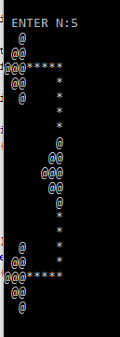

**Code::**

#include<stdio.h>

int main()

{

int i,n,j;

printf("\n ENTER N:");

scanf("%d",&n);

for(i=1;i<=n+n/2;i++)

{

if(i>=1 && i<=n/2)

{

for(j=n/2;j>=i;j--)

printf(" ");

for(j=1;j<=i;j++)

printf("@");

printf("\n");

}

else if(i>n/2 && i<=n)

{

if(i==n/2+1)

{

for(j=1;j<=n/2+1;j++)

printf("@");

for(j=1;j<=n;j++)

printf("*");

printf("\n");

}

else

{

for(j=n/2+2;j<=i;j++)

printf(" ");

for(j=n;j>=i;j--)

printf("@");

for(j=1;j<=n-1;j++)

printf(" ");

for(j=1;j<=1;j++)

printf("*");

printf("\n");

}

}

else

{

for(j=1;j<=n/2+1;j++)

printf(" ");

for(j=1;j<=n-1;j++)

printf(" ");

for(j=1;j<=1;j++)

printf("*");

printf("\n");

}

}

for(i=1;i<=n+n/2;i++)

{

if(i>=1 && i<=n/2+1)

{

for(j=1;j<=n;j++)

printf(" ");

for(j=n/2;j>=i;j--)

printf(" ");

for(j=1;j<=i;j++)

printf("@");

printf("\n");

}

else if(i>n/2+1 && i<=n)

{

for(j=1;j<=n;j++)

printf(" ");

for(j=n/2+2;j<=i;j++)

printf(" ");

for(j=n;j>=i;j--)

printf("@");

printf("\n");

}

else

{

for(j=1;j<=n+n/2;j++)

printf(" ");

for(j=1;j<=1;j++)

printf("*");

printf("\n");

}

}

for(i=1;i<=n+n/2;i++)

{

if(i>=1 && i<=n/2)

{

for(j=n/2;j>=i;j--)

printf(" ");

for(j=1;j<=i;j++)

printf("@");

for(j=1;j<=n-1;j++)

printf(" ");

for(j=1;j<=1;j++)

printf("*");

printf("\n");

}

else

{

if(i==n/2+1)

{

for(j=1;j<=n/2+1;j++)

printf("@");

for(j=1;j<=n;j++)

printf("*");

printf("\n");

}

else

{

for(j=n/2+2;j<=i;j++)

printf(" ");

for(j=n;j>=i;j--)

printf("@");

printf("\n");

}

}

}

return 0;

}

1. **WAP to conquer the below pattern very easily.**

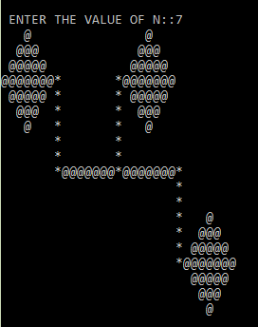

**Code::**

#include<stdio.h>

int main()

{

int n,i,j;

printf("\n ENTER THE VALUE OF N::");

scanf("%d",&n);

for(i=1;i<=n+n/2;i++)

{

if(i>=1 && i<=n/2)

{

for(j=n/2;j>=i;j--)

printf(" ");

for(j=1;j<=i;j++)

printf("@");

for(j=1;j<i;j++)

printf("@");

for(j=n/2;j>=i;j--)

printf(" ");

for(j=1;j<=n+2;j++)

printf(" ");

for(j=n/2;j>=i;j--)

printf(" ");

for(j=1;j<=i;j++)

printf("@");

for(j=1;j<i;j++)

printf("@");

printf("\n");

}

else

{

if(i==n/2+1)

{

for(j=1;j<=n;j++)

printf("@");

for(j=1;j<=1;j++)

printf("*");

for(j=1;j<=n;j++)

printf(" ");

for(j=1;j<=1;j++)

printf("*");

for(j=1;j<=n;j++)

printf("@");

printf("\n");

}

else

{

if(i>n/2+1 && i<=n)

{

for(j=n/2+2;j<=i;j++)

printf(" ");

for(j=n;j>=i;j--)

printf("@");

for(j=n;j>i;j--)

printf("@");

for(j=n/2+2;j<=i;j++)

printf(" ");

for(j=1;j<=1;j++)

printf("*");

for(j=1;j<=n;j++)

printf(" ");

for(j=1;j<=1;j++)

printf("*");

for(j=n/2+2;j<=i;j++)

printf(" ");

for(j=n;j>=i;j--)

printf("@");

for(j=n;j>i;j--)

printf("@");

printf("\n");

}

else if(i==n+n/2)

{

for(j=1;j<=n;j++)

printf(" ");

for(j=1;j<=1;j++)

printf("*");

for(j=1;j<=n;j++)

printf("@");

for(j=1;j<=1;j++)

printf("*");

for(j=1;j<=n;j++)

printf("@");

for(j=1;j<=1;j++)

printf("*");

printf("\n");

}

else

{

for(j=1;j<=n;j++)

printf(" ");

for(j=1;j<=1;j++)

printf("*");

for(j=1;j<=n;j++)

printf(" ");

for(j=1;j<=1;j++)

printf("*");

printf("\n");

}

}

}

}

for(i=1;i<=(n+n/2)-1;i++)

{

if(i>=1 && i<=n/2-1)

{

for(j=1;j<=3*n+2;j++)

printf(" ");

for(j=1;j<=1;j++)

printf("*");

printf("\n");

}

else

{

if(i>=n/2 && i<=n-1)

{

for(j=1;j<=3*n+2;j++)

printf(" ");

for(j=1;j<=1;j++)

printf("*");

for(j=n-1;j>i;j--)

printf(" ");

for(j=n/2;j<=i;j++)

printf("@");

for(j=n/2;j<i;j++)

printf("@");

printf("\n");

}

else

{

for(j=1;j<=3*n+3;j++)

printf(" ");

for(j=n;j<=i;j++)

printf(" ");

for(j=(n+n/2)-1;j>=i;j--)

printf("@");

for(j=(n+n/2)-1;j>i;j--)

printf("@");

printf("\n");

}

}

}

return 0;

}

1. **WAP to solve this beautiful crown like pattern given below.**

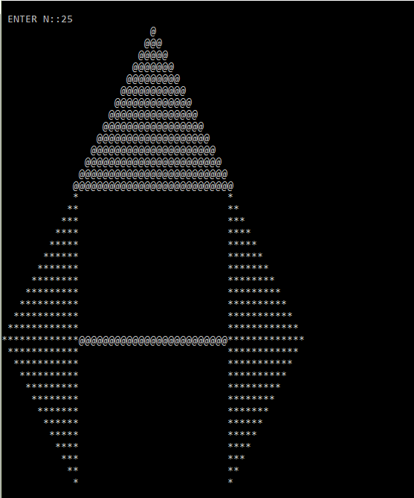

**Code::**

#include<stdio.h>

int main()

{

int i,j,n,k=1;

printf("\n ENTER N::");

scanf("%d",&n);

/*for upper Mountain. */

for(i=1;i<=n/2+2;i++)

{

for(j=n;j>=i;j--)

printf(" ");

for(j=1;j<=k;j++)

printf("@");

printf("\n");

k+=2;

}

/* For the next both side pyramid with gap in middle. */

for(i=1;i<=n/2;i++)

{

for(j=i;j<=n/2;j++)

printf(" ");

for(j=1;j<=i;j++)

printf("*");

for(j=1;j<=n;j++)

printf(" ");

for(j=1;j<=i;j++)

printf("*");

printf("\n");

}

/*for the next left structure. */

for(i=1;i<=n/2+1;i++)

{

/* For the first middle line. */

if(i==1)

{

for(j=1;j<=n/2+1;j++)

printf("*");

for(j=1;j<=n;j++)

printf("@");

for(j=1;j<=n/2+1;j++)

printf("*");

}

/* For the last left lines structures. */

else

{

for(j=2;j<=i;j++)

printf(" ");

for(j=i;j<=n/2+1;j++)

printf("*");

for(j=1;j<=n;j++)

printf(" ");

for(j=i;j<=n/2+1;j++)

printf("*");

}

printf("\n");

}

return 0;

}

1. **WAP to Solve this pattern.**

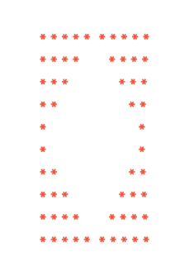

**Code::**

#include<stdio.h>

int main()

{

int i,j,n;

printf("\n ENTER N::");

scanf("%d",&n);

for(i=1;i<=n;i++)

{

for(j=n;j>=i;j--)

printf("*");

for(j=2;j<=i;j++)

printf(" ");

for(j=2;j<=i;j++)

printf(" ");

for(j=n;j>=i;j--)

printf("*");

printf("\n");

}

for(i=1;i<=n;i++)

{

for(j=1;j<=i;j++)

printf("*");

for(j=n;j>i;j--)

printf(" ");

for(j=n;j>i;j--)

printf(" ");

for(j=1;j<=i;j++)

printf("*");

printf("\n");

}

return 0;

}

1. **WAP to Solve this pattern.**

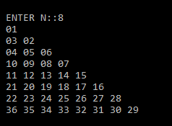

**Code::**

#include<stdio.h>

int main()

{

int i,j,t,n,p=0;

printf("\n ENTER N::");

scanf("%d",&t);

n=1;

for(i=1;i<=t;i++)

{

if(i%2!=0)

{

n=p+i;

for(j=1;j<=i;j++)

{

printf(" %02d",n);

n++;

}

}

else

{

p=n+i-1;

for(j=1;j<=i;j++)

{

printf(" %02d",p);

p--;

}

}

printf("\n");

}

return 0;

}

1. **WAP to Solve this pattern.**

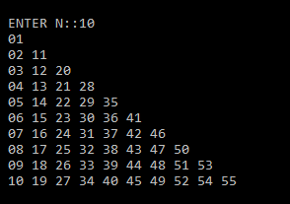

**Code::**

#include<stdio.h>

int main()

{

int i,j,n,p=0,t,m,k;

printf("\n ENTER N::");

scanf("%d",&n);

for(i=1;i<=n;i++)

{

t=n;

for(j=1;j<=i;j++)

{

if(j==1)

{

p=i;

printf(" %02d",p);

}

else

{

p=p+t;

printf(" %02d",p);

}

t--;

}

printf("\n");

}

return 0;

}

1. **WAP to Solve this pattern.**

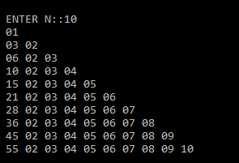

**Code::**

#include<stdio.h>

int main()

{

int i,j,n,p=0,t=1;

printf("\n ENTER N::");

scanf("%d",&n);

for(i=1;i<=n;i++)

{

p=p+t;

for(j=1;j<=i;j++)

{

if(j==1)

{

printf(" %02d",p);

}

else

{

printf(" %02d",j);

}

}

printf("\n");

t++;

}

return 0;

}

1. **WAP to Solve this pattern.**

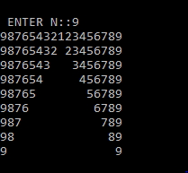

**Code::**

#include<stdio.h>

int main()

{

int i,j,n,k=1,m;

printf("\n ENTER N::");

scanf("%d",&n);

for(i=1;i<=n;i++)

{

for(j=n;j>=i;j--)

printf("%d",j);

for(j=3;j<=k;j++)

printf(" ");

m=i;

for(j=n;j>=i;j--)

{

if(i==1)

{

if(j!=n)

printf("%d",m);

m++;

}

else

{

printf("%d",m);

m++;

}

}

printf("\n");

k+=2;

}

return 0;

}